Irregular Curvilinear Cross Sections

Definition
# Source: AI Source: Provided by: [Data Path: Persons Table -> ID Column: 1, Name_En Column: Motasem Essam] -> From: [ChatGPT] on [7/25/2026]
An Irregular Curvilinear Cross Section is a two-dimensional region formed when a plane intersects a three-dimensional solid and the resulting boundary contains curved portions that do not form a standard circle, ellipse, or other regular geometric curve.
Its boundary may consist of one or more irregular curves, and its shape depends on the geometry of the solid and the position and orientation of the cutting plane.
Irregular curvilinear sections can occur in solids with complex curved surfaces, particularly tori and other non-standard curved solids. A torus, for example, can produce crescent-shaped, U-shaped, and kidney-shaped sections when intersected by suitably oriented planes.

Geometric Representation
# Source: AI Source: Provided by: [Data Path: Persons Table -> ID Column: 1, Name_En Column: Motasem Essam] -> From: [ChatGPT] on [7/25/2026]
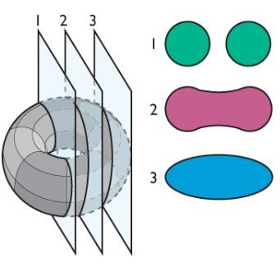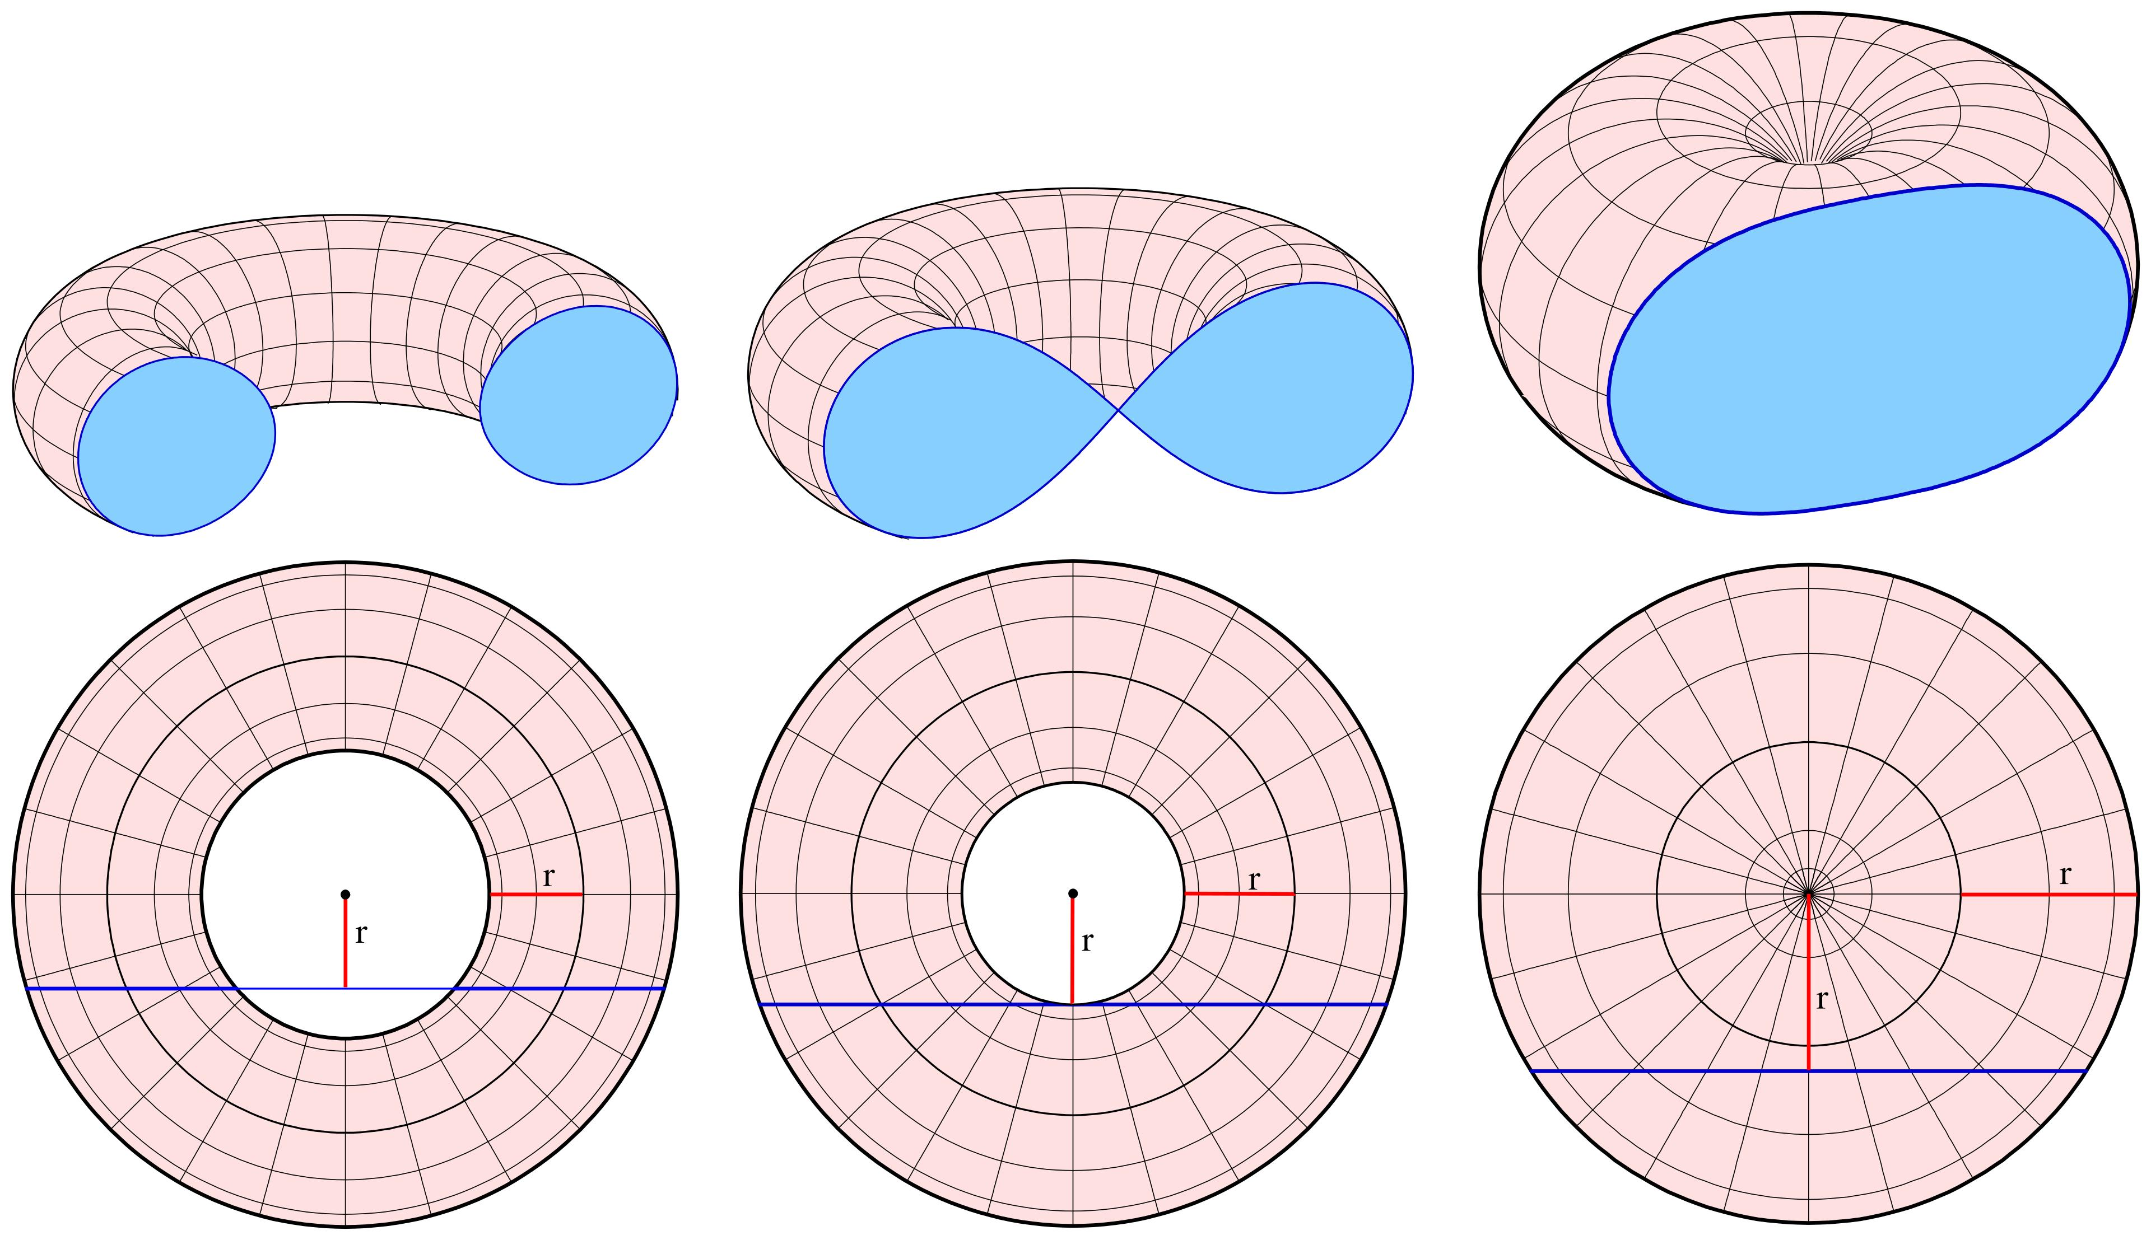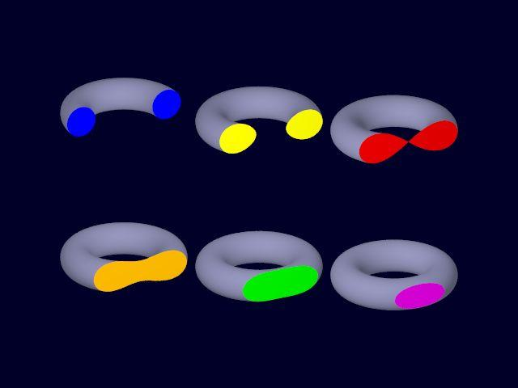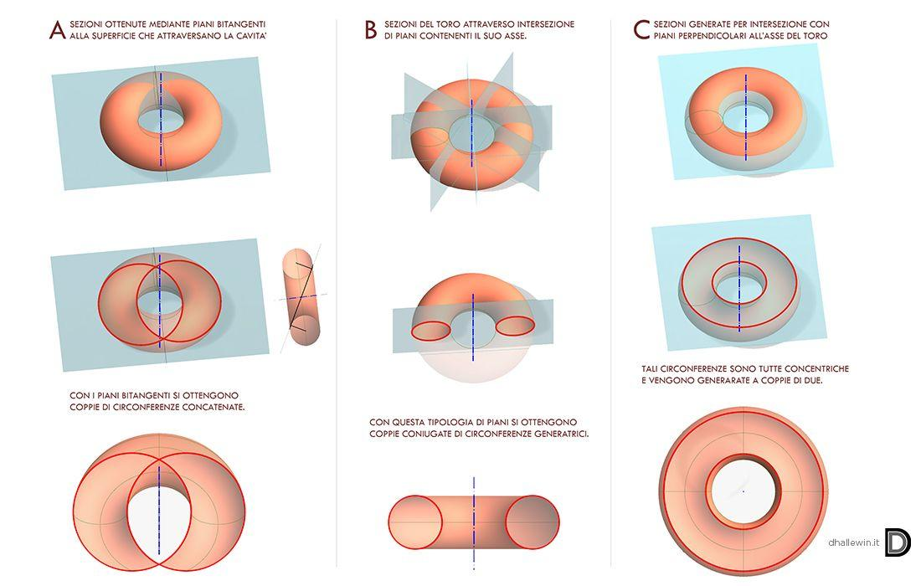

Geometric Structure
# Source: AI Source: Provided by: [Data Path: Persons Table -> ID Column: 1, Name_En Column: Motasem Essam] -> From: [ChatGPT] on [7/25/2026]
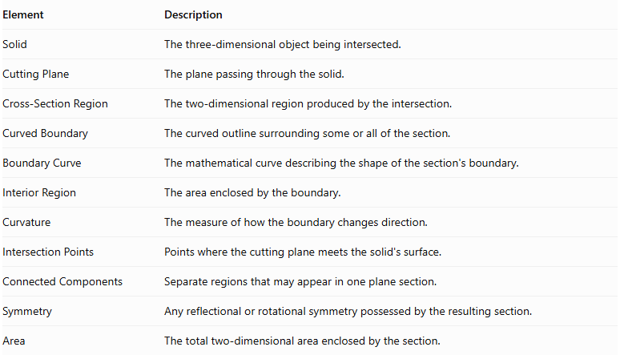
Element | Description
Solid | The three-dimensional object being intersected.
Cutting Plane | The plane passing through the solid.
Cross-Section Region | The two-dimensional region produced by the intersection.
Curved Boundary | The curved outline surrounding some or all of the section.
Boundary Curve | The mathematical curve describing the shape of the section's boundary.
Interior Region | The area enclosed by the boundary.
Curvature | The measure of how the boundary changes direction.
Intersection Points | Points where the cutting plane meets the solid's surface.
Connected Components | Separate regions that may appear in one plane section.
Symmetry | Any reflectional or rotational symmetry possessed by the resulting section.
Area | The total two-dimensional area enclosed by the section.

Main Characteristics
# Source: AI Source: Provided by: [Data Path: Persons Table -> ID Column: 1, Name_En Column: Motasem Essam] -> From: [ChatGPT] on [7/25/2026]
- The cross section contains curved boundary portions.
- Its outline is not necessarily a standard circle or ellipse.
- Its shape depends strongly on the geometry of the solid.
- Its shape changes according to the cutting plane's position and orientation.
- It may be a single connected region or consist of multiple disconnected regions.
- It may be symmetric or asymmetric.
- Its boundary can contain different curved portions.
- Its area may require integration or numerical approximation rather than a simple standard formula.

Types of Irregular Curvilinear Cross Sections
# Source: AI Source: Provided by: [Data Path: Persons Table -> ID Column: 1, Name_En Column: Motasem Essam] -> From: [ChatGPT] on [7/25/2026]
The following are useful descriptive shape categories. They are not all distinct mathematical curve families; some describe the overall appearance of the resulting region.

Crescent-Shaped Cross Section
# Source: AI Source: Provided by: [Data Path: Persons Table -> ID Column: 1, Name_En Column: Motasem Essam] -> From: [ChatGPT] on [7/25/2026]
A crescent-shaped cross section is a curved region resembling a crescent or sickle.
Characteristics:
- Has an inward-curving boundary and an outward-curving boundary.
- Usually forms a single connected region.
- Can result from certain oblique plane intersections of a torus.

U-Shaped Cross Section
# Source: AI Source: Provided by: [Data Path: Persons Table -> ID Column: 1, Name_En Column: Motasem Essam] -> From: [ChatGPT] on [7/25/2026]
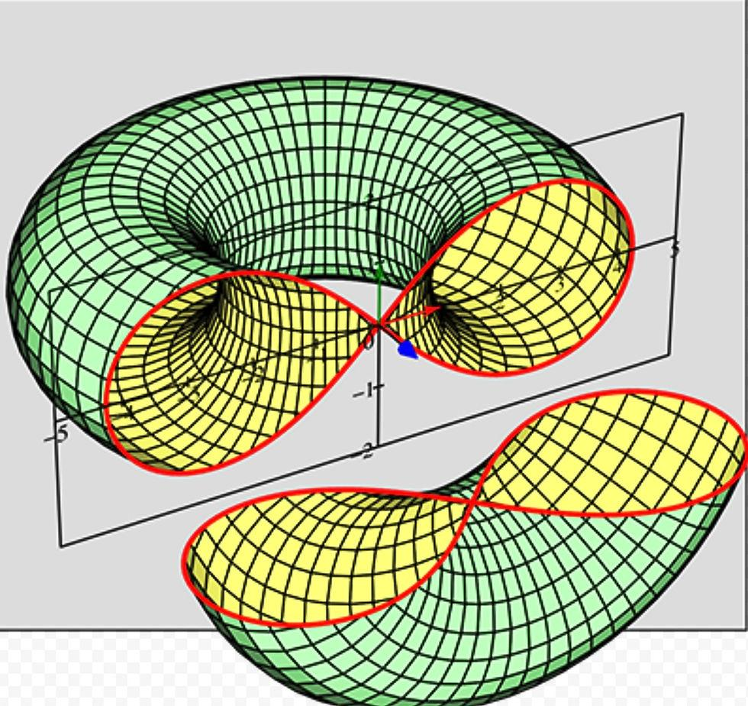
A U-shaped cross section is a curved region whose overall outline resembles the letter U.
Characteristics:
- Has an open-looking concave outline, although the actual cross-sectional boundary is closed.
- May have two arms connected by a curved bottom region.
- Can occur among oblique toric sections.

Kidney-Shaped Cross Section
# Source: AI Source: Provided by: [Data Path: Persons Table -> ID Column: 1, Name_En Column: Motasem Essam] -> From: [ChatGPT] on [7/25/2026]
A kidney-shaped cross section is an irregular curved region resembling the outline of a kidney.
Characteristics:
- Has a concave indentation along one side.
- Its opposite side is generally convex.
- Can appear in certain oblique sections of a torus.
- May occur as one of multiple disconnected components.

Lobed Curvilinear Cross Section
# Source: AI Source: Provided by: [Data Path: Persons Table -> ID Column: 1, Name_En Column: Motasem Essam] -> From: [ChatGPT] on [7/25/2026]
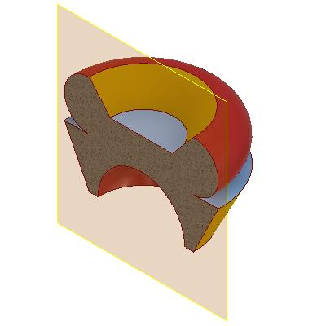
A lobed curvilinear cross section contains one or more rounded protrusions along its boundary.
Characteristics:
- Has multiple curved outward portions.
- May have inward indentations between neighboring lobes.
- Its boundary is not a simple circular or elliptical curve.

Wavy Curvilinear Cross Section
# Source: AI Source: Provided by: [Data Path: Persons Table -> ID Column: 1, Name_En Column: Motasem Essam] -> From: [ChatGPT] on [7/25/2026]
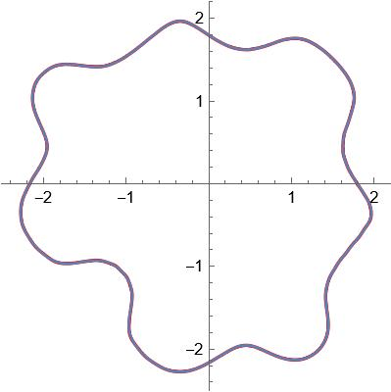
A wavy curvilinear cross section has a boundary that repeatedly bends inward and outward.
Characteristics:
- Contains alternating convex and concave portions.
- May have several local maximum and minimum curvature regions.
- Its precise shape depends on the intersected solid and plane.

Multi-Component Curvilinear Cross Section
# Source: AI Source: Provided by: [Data Path: Persons Table -> ID Column: 1, Name_En Column: Motasem Essam] -> From: [ChatGPT] on [7/25/2026]
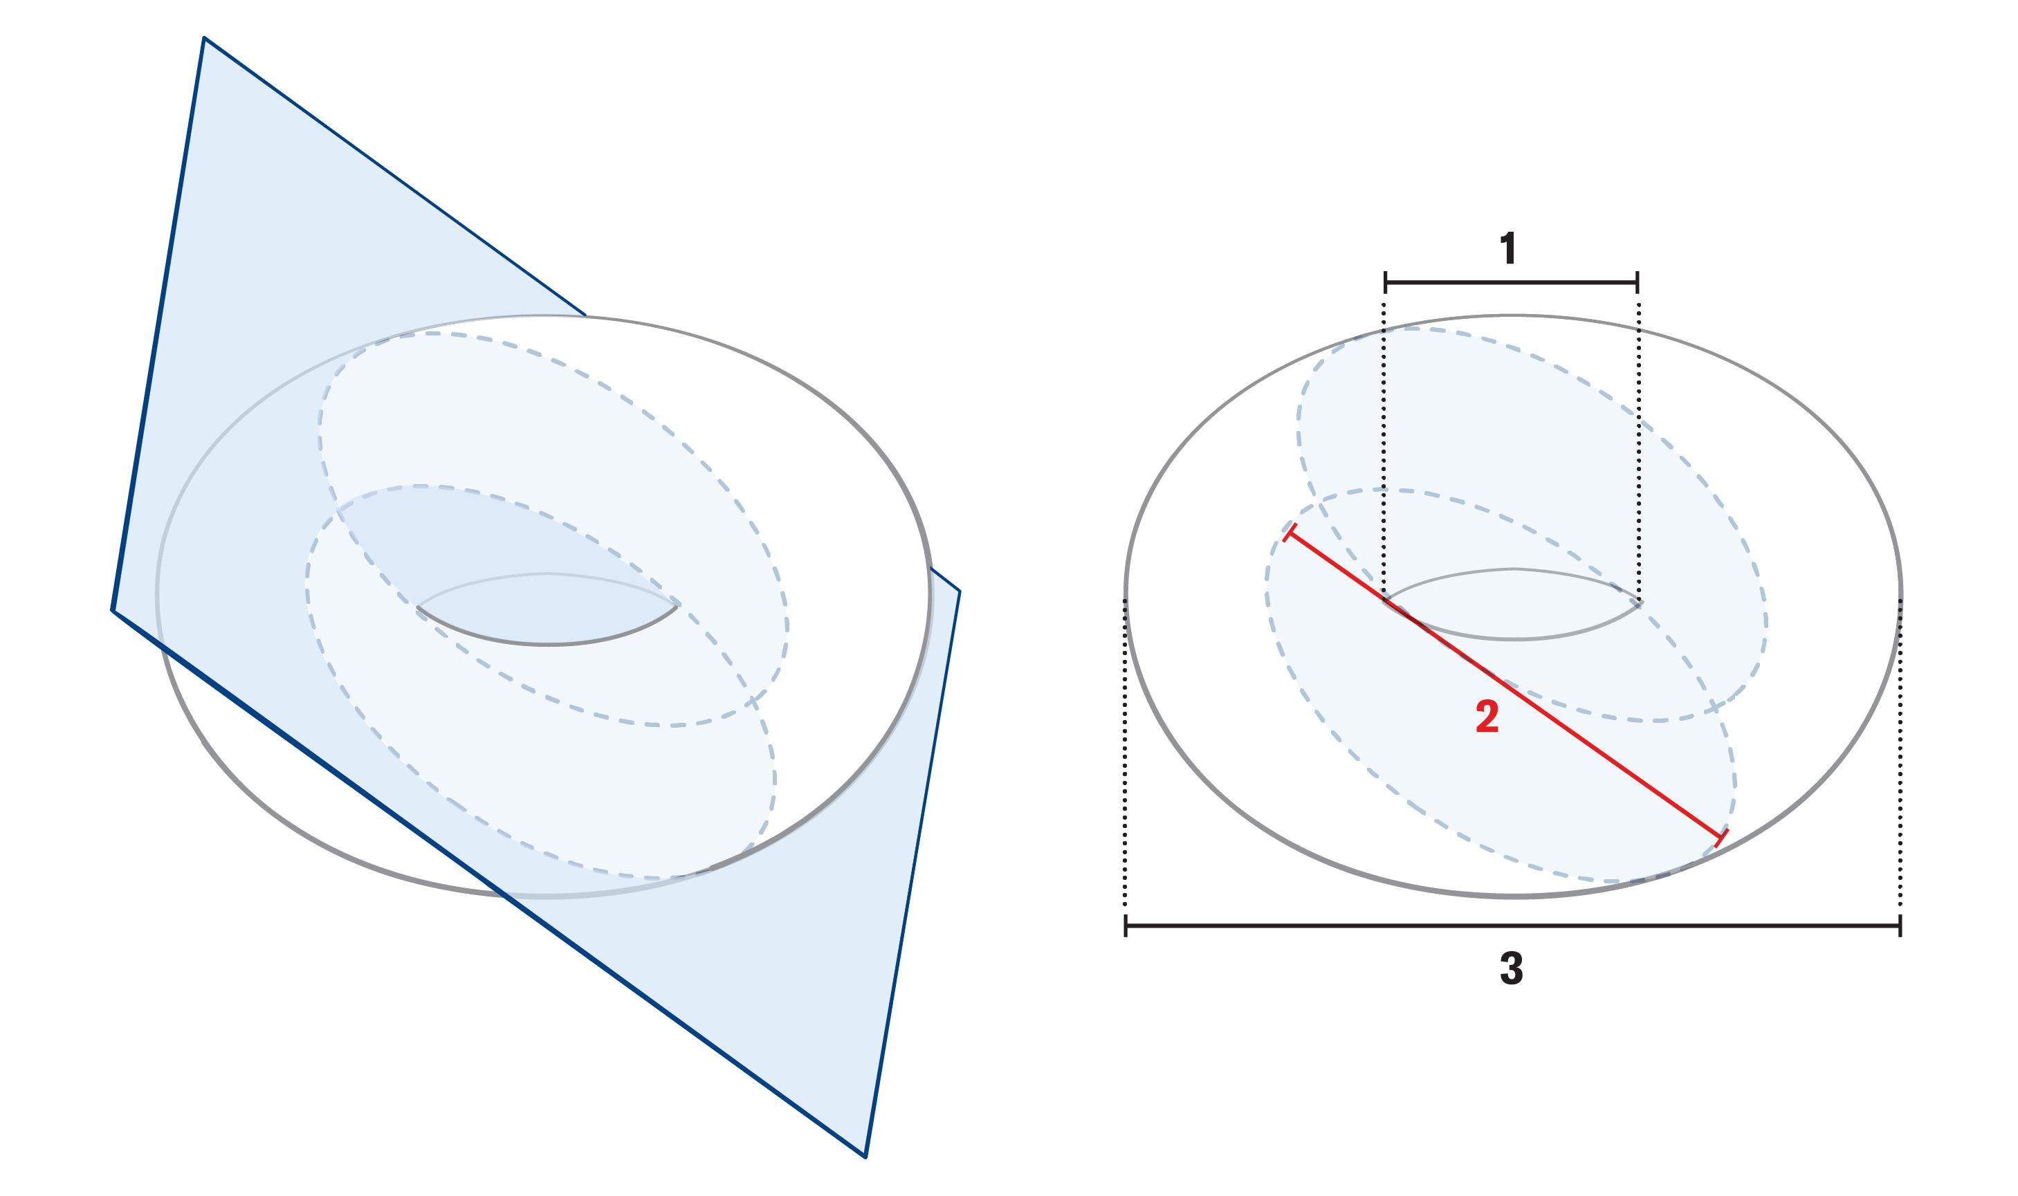
A multi-component curvilinear cross section occurs when one cutting plane produces two or more separate curved regions.
Characteristics:
- Contains disconnected regions within the same cutting plane.
- Each component may have an irregular curved boundary.
- The components may be symmetric or asymmetric.
Torus intersections provide examples of these different shapes, including transitions between crescent-shaped, U-shaped, and disconnected kidney-shaped curves.

Examples According to Solid Type

Torus
# Source: AI Source: Provided by: [Data Path: Persons Table -> ID Column: 1, Name_En Column: Motasem Essam] -> From: [ChatGPT] on [7/25/2026]
A torus is one of the most important examples of a solid that can produce irregular curvilinear cross sections.
- An oblique plane can produce a crescent-shaped section.
- Other plane positions can produce U-shaped sections.
- Certain sections can produce two disconnected kidney-shaped curves.
- The resulting shapes depend on the torus dimensions and the plane's position and orientation.
The general plane intersection of a torus is called a Toric Section. A special family of toric sections is called Spiric Sections.

Spindle Torus
# Source: AI Source: Provided by: [Data Path: Persons Table -> ID Column: 1, Name_En Column: Motasem Essam] -> From: [ChatGPT] on [7/25/2026]
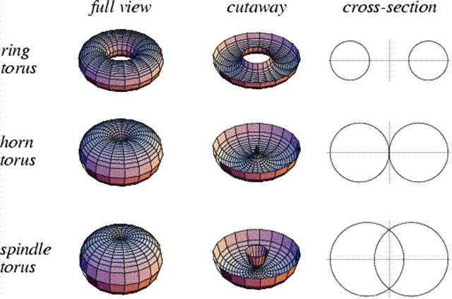
A spindle torus is a self-intersecting torus produced when the minor radius is greater than the major radius.
Its plane intersections can produce more complicated curved boundaries, including sections with self-intersections or multiple components.

Non-Convex Curved Solids
# Source: AI Source: Provided by: [Data Path: Persons Table -> ID Column: 1, Name_En Column: Motasem Essam] -> From: [ChatGPT] on [7/25/2026]
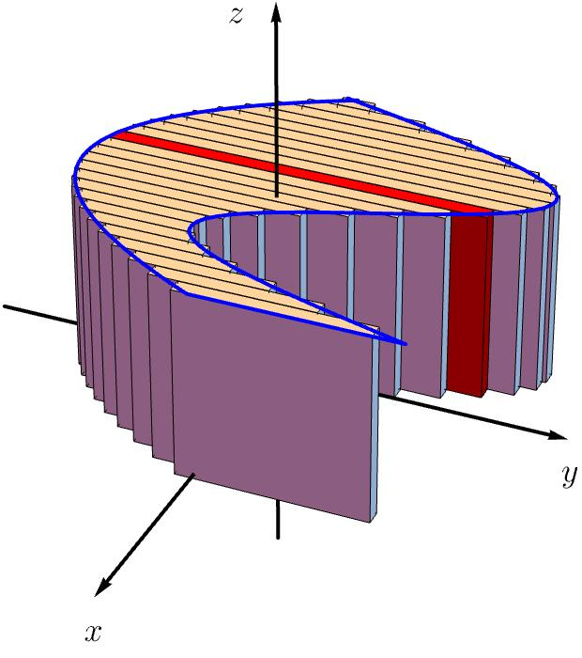
Non-convex curved solids can produce irregular curvilinear sections when a plane intersects their curved surfaces.
Possible characteristics include:
- Concave boundaries.
- Multiple disconnected regions.
- Unequal curved portions.
- Complex combinations of inward and outward curves.

Composite Curved Solids
# Source: AI Source: Provided by: [Data Path: Persons Table -> ID Column: 1, Name_En Column: Motasem Essam] -> From: [ChatGPT] on [7/25/2026]
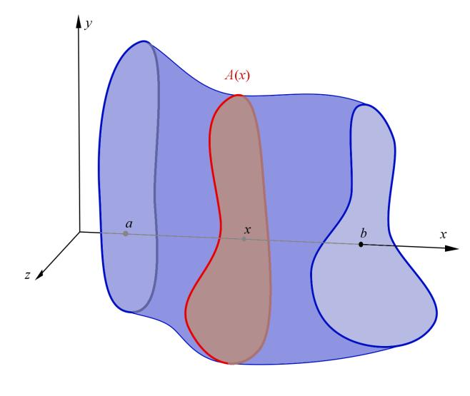
A composite curved solid consists of two or more connected or overlapping curved components.
A plane intersecting such a solid may produce a section containing multiple curved boundary portions, potentially forming an irregular combined shape.

Mathematical Representation

General Plane Equation
# Source: AI Source: Provided by: [Data Path: Persons Table -> ID Column: 1, Name_En Column: Motasem Essam] -> From: [ChatGPT] on [7/25/2026]
A cutting plane in three-dimensional space is represented by:
$$ax+by+cz+d=0$$
Where:
- $a,b,c$ define the plane's normal vector.
- $d$ determines its position.
- $x,y,z$ are coordinates in three-dimensional space.

General Cross-Section Representation
# Source: AI Source: Provided by: [Data Path: Persons Table -> ID Column: 1, Name_En Column: Motasem Essam] -> From: [ChatGPT] on [7/25/2026]
Let $S$ represent the solid and $P$ the cutting plane.
The cross section is:
$$C=S∩P$$
The resulting region is determined by the points that belong to both the solid and the plane.
Its boundary is:
$$∂C$$
For irregular curvilinear cross sections, this boundary may be described by one or more nonlinear equations.

Toric Section Equation
# Source: AI Source: Provided by: [Data Path: Persons Table -> ID Column: 1, Name_En Column: Motasem Essam] -> From: [ChatGPT] on [7/25/2026]
A standard ring torus centered at the origin, with its axis along the $z$-axis, is represented by:
$$(x^{2}+y^{2}+z^{2}+R^{2}-r^{2})^{2}=4R^{2}(x^{2}+y^{2})$$
Where:
- $R$ = major radius.
- $r$ = minor radius.
- $R>r$ for a ring torus.
For a vertical cutting plane:
$$y=s$$
Substitution produces the toric section equation:
$$(x^{2}+z^{2}+R^{2}+s^{2}-r^{2})^{2}=4R^{2}(x^{2}+s^{2})$$
This equation describes the intersection curve in the cutting plane. Depending on the value of $s$, the resulting curve can have different shapes and numbers of connected components.

Cross-Sectional Area
# Source: AI Source: Provided by: [Data Path: Persons Table -> ID Column: 1, Name_En Column: Motasem Essam] -> From: [ChatGPT] on [7/25/2026]
For an irregular curvilinear region $C$, its area can be calculated using a double integral:
$$A={iint}_{C}dA$$
In Cartesian coordinates:
$$A={iint}_{C}dx dy$$
For a region bounded by suitable functions:
$$A=\int_{a}^{b}{[f(x)-g(x)]} dx$$
Where:
- $f(x)$ represents the upper boundary.
- $g(x)$ represents the lower boundary.
- $a,b$ define the integration limits.
For multiple disconnected components:
$$A_{\text{total}}=A_{1}+A_{2}+⋯+A_{n}$$

Perimeter
# Source: AI Source: Provided by: [Data Path: Persons Table -> ID Column: 1, Name_En Column: Motasem Essam] -> From: [ChatGPT] on [7/25/2026]
The perimeter is the total length of the curved boundary.
For a boundary represented parametrically by:
$$x=x(t), y=y(t)$$
Its arc length is:
$$L=\int_{t_{1}}^{t_{2}}{\sqrt{{\left(\frac{dx}{dt}\right)}^{2}+{\left(\frac{dy}{dt}\right)}^{2}}} dt$$
For multiple boundary curves, their lengths are added.

Mathematical Properties
# Source: AI Source: Provided by: [Data Path: Persons Table -> ID Column: 1, Name_En Column: Motasem Essam] -> From: [ChatGPT] on [7/25/2026]
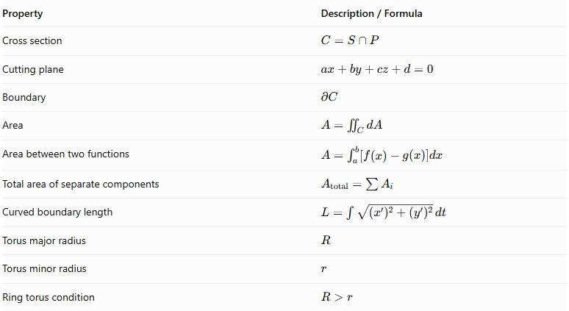
Property | Description / Formula
Cross section | $$C=S∩P$$
Cutting plane | $$ax+by+cz+d=0$$
Boundary | $$∂C$$
Area | $$A={iint}_{C}dA$$
Area between two functions | $$A=\int_{a}^{b}{[f(x)-g(x)]dx}$$
Total area of separate components | $$A_{\text{total}}=\sum{A_{i}}$$
Curved boundary length | $$L=\int{\sqrt{(x')^{2}+(y')^{2}}} dt$$
Torus major radius | $$R$$
Torus minor radius | $$r$$
Ring torus condition | $$R>r$$

Irregular Curvilinear Cross Sections vs. Other Cross-Section Shapes
# Source: AI Source: Provided by: [Data Path: Persons Table -> ID Column: 1, Name_En Column: Motasem Essam] -> From: [ChatGPT] on [7/25/2026]
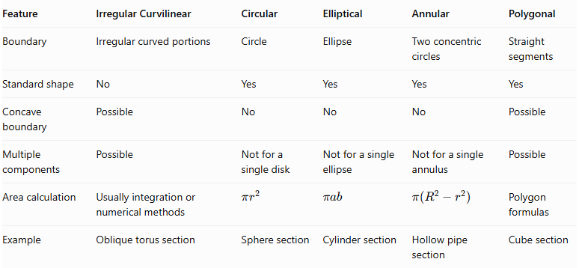
Feature | Irregular Curvilinear | Circular | Elliptical | Annular | Polygonal
Boundary | Irregular curved portions | Circle | Ellipse | Two concentric circles | Straight segments
Standard shape | No | Yes | Yes | Yes | Yes
Concave boundary | Possible | No | No | No | Possible
Multiple components | Possible | Not for a single disk | Not for a single ellipse | Not for a single annulus | Possible
Area calculation | Usually integration or numerical methods | $$πr^{2}$$ | $$πab$$ | $$π(R^{2}-r^{2})$$ | Polygon formulas
Example | Oblique torus section | Sphere section | Cylinder section | Hollow pipe section | Cube section

Applications
# Source: AI Source: Provided by: [Data Path: Persons Table -> ID Column: 1, Name_En Column: Motasem Essam] -> From: [ChatGPT] on [7/25/2026]
- Advanced Geometry: Studying plane intersections of complex curved surfaces.
- Computer Graphics: Modeling complex curved boundaries and cross-sectional profiles.
- Mechanical Engineering: Analyzing complex curved components and their sections.
- Industrial Design: Designing non-standard curved structures and components.
- Mathematical Modeling: Investigating toric sections, spiric sections, and other nonlinear curves.
- Computational Geometry: Calculating areas, boundaries, and connected components of complex intersections.
- Manufacturing: Analyzing the profiles produced by cutting complex curved objects.

Main Classification
# Source: AI Source: Provided by: [Data Path: Persons Table -> ID Column: 1, Name_En Column: Motasem Essam] -> From: [ChatGPT] on [7/25/2026]
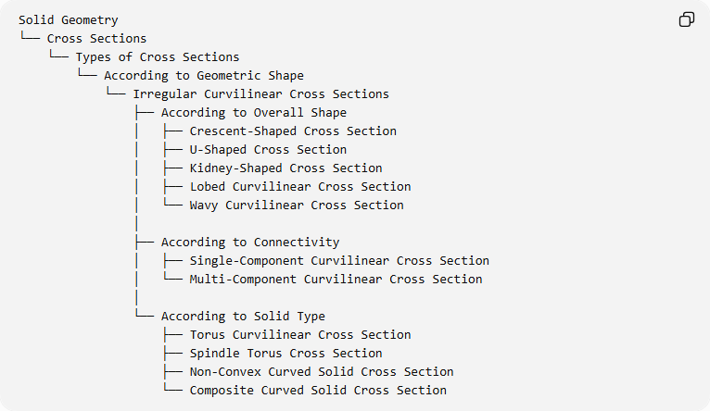
Solid Geometry
└── Cross Sections
└── Types of Cross Sections
└── According to Geometric Shape
└── Irregular Curvilinear Cross Sections
├── According to Overall Shape
│ ├── Crescent-Shaped Cross Section
│ ├── U-Shaped Cross Section
│ ├── Kidney-Shaped Cross Section
│ ├── Lobed Curvilinear Cross Section
│ └── Wavy Curvilinear Cross Section
│
├── According to Connectivity
│ ├── Single-Component Curvilinear Cross Section
│ └── Multi-Component Curvilinear Cross Section
│
└── According to Solid Type
├── Torus Curvilinear Cross Section
├── Spindle Torus Cross Section
├── Non-Convex Curved Solid Cross Section
└── Composite Curved Solid Cross Section

Key Points
# Source: AI Source: Provided by: [Data Path: Persons Table -> ID Column: 1, Name_En Column: Motasem Essam] -> From: [ChatGPT] on [7/25/2026]
- Irregular curvilinear cross sections are regions bounded by non-standard curved outlines.
- Their shapes depend on the solid and the cutting plane.
- They may contain concave and convex boundary portions.
- They can consist of one connected region or multiple disconnected regions.
- Toric sections are important examples of irregular curved plane intersections.
- Crescent-shaped, U-shaped, and kidney-shaped sections can occur when cutting a torus.
- Their area and perimeter generally require integration or numerical approximation.

Conclusion
# Source: AI Source: Provided by: [Data Path: Persons Table -> ID Column: 1, Name_En Column: Motasem Essam] -> From: [ChatGPT] on [7/25/2026]
Irregular Curvilinear Cross Sections are two-dimensional regions formed by intersecting complex curved solids with planes. Their boundaries do not necessarily follow standard geometric curves such as circles or ellipses. They can produce a variety of shapes, including crescent-shaped, U-shaped, kidney-shaped, and multi-component regions. They are particularly important in the study of toric sections, non-convex curved solids, and advanced three-dimensional geometry.

